
Bacha Khan University, Charsadda
_

Attached
02 No. of
Passport
Size Pictures with white Background

Degree in Absentia Form
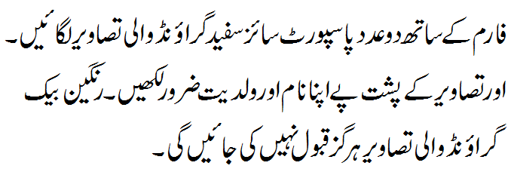

University Registration No:

Title of Degree:

1. Name (in Block letters) ____________________________________________________
2. Father’s Name (in Block letters)_____________________________________________
3. Name of Examination Passed ____________________________Roll No_____________
Year/Session __________________ Annual/Supply.(Attach final year DMC photocopy)
4. Tick whether passed as Regular Student OR Private Candidate
5. Institution attended: _______________________________________________________
6. District of Domicile: _______________________________________________________
7. Permanent Address ________________________________________________________
___________________________________________________Phone No ____________
8. Email Address: ___________________________________________________________

9. N.I.C No. (Attach attested Copy)
I have completed all the requirements for award of Degree and have deposited
Rs._________________ Vide Receipt No.________________ date ____________ attached

UDC/ CO:______________ ACE:______________ Controller of Examination:____________

Attestation From

Head of Department/Institute/Principal/Gazetted Officer
(Please Read instruction No.2 overleaf)

Signature ………………………………. Signature of the Candidate
Name …………………………………...

Office Seal…………………………….. Form Submission Date: ____________________________

ACKNOWLEDGEMENT (For applicant)
Received degree form of Mr/Mrs ____________________________________________________
S/D/O ____________________________________Exam.__________ Reg. No. _____________
Session ___________Annual/Supply Roll No. ________Form Submission Date ______________
Normal
Category (A)
Urgent
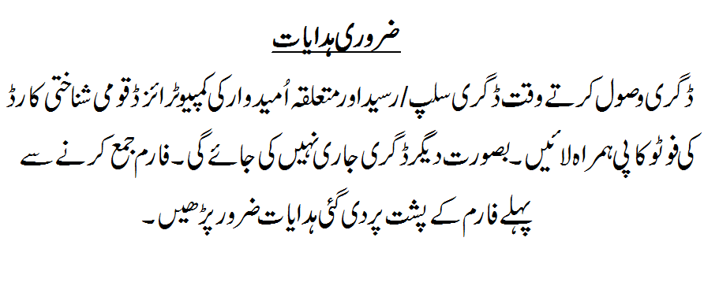
Category (B)

___________________
Dealing Asstt: (Degree Section)
Bacha Khan University, Charsadda
(P.T.O)
INSTRUCTIONS FOR THE CANDIDATES

IMPORTANT NOTE:
This form should be filled in accordance with the following instructions Incomplete form will not be entertained and shall be returned OR be kept pending till the deficiency is removed.
1. Following documents shall be attached with the form:
A. For Original Degree

S.No. | Discipline of Degree | Attached Documents for Annual System | Attached Documents for Semester System
1. | Bachelor | - Original Bank Receipt or Bank Draft for the fee deposited.  - Attested Photocopy of Matric Certificate  - Verified Photocopy of FA/F.Sc Certificate.  - Attested DMC’s Photocopies of Bachelor (Part-I & Part-II).  - Attested Photocopy of CNIC.  - Clearance Form for Regular Students. | - Original Bank Receipt or Bank Draft for the fee deposited.  - Attested Photocopy of Matric Certificate  - Verified Photocopy of FA/F.Sc Certificate.  - Attested Photocopy of Final Transcript.  - Attested Photocopy of CNIC.  - Clearance Form.
2. | Master | - Original Bank Receipt or Bank Draft for the fee deposited.  - Attested Photocopy of Matric Certificate  - Verified Photocopy of Bachelor’s Degree.  - Attested DMC’s Photocopies of (Previous & Final exams)  - Attested Photocopy of CNIC.  - Clearance Form for Regular Students. | - Original Bank Receipt or Bank Draft for the fee deposited.  - Attested Photocopy of Matric Certificate  - Verified Photocopy of Bachelor’s Degree.  - Attested Photocopy ofFinal Transcript.  - Attested Photocopy of CNIC.  - Clearance Form.
3. | MS/M.Phil |  | - Original Bank Receipt or Bank Draft for the fee deposited.  - Attested Photocopy of Matric Certificate  - Verified Photocopy of Master’s Degree.  - Attested Photocopy ofFinal Transcript.  - Attested Photocopy of CNIC.  - Notification from Secrecy  - Clearance Form.
4. | Ph.D |  | - Original Bank Receipt or Bank Draft for the fee deposited.  - Attested Photocopy of Matric Certificate  - Verified Photocopy of MS/M.Phil Degree.  - Attested Photocopy ofFinal Transcript.  - Attested Photocopy of CNIC.  - Clearance Form.

B. Duplicate Degree
i. Original Degree (If available) ii. Copy of Matric Certificate
iii Copy of D.M.C of the relevant Exam iv. Copy of Intermediate Certificate
v. Cutting of at least two newspapers vi. Copy of C.N.I.C
vii. F.I.R viii. Affidavit (In Original)
ix. Original Bank Receipt or Bank Draft for the fee deposited. Fee remitted through Money Order is not be accepted.
2. Regular students are required to attest this form, all documents and photographs from the head of the concerned Department/Institution while private candidates are required to attest all the aforementioned documents from a Gazetted Government officer. The attestation officer will be held accountable for wrong attestation.
3. The office will not be held responsible for delay in preparation of degree in stipulated period due to incomplete/wrong information OR Non-availability of Registrar/Vice-Chancellor.
4. In case of Examination where the specialization has to be mentioned in the degree certificate to the effect is to be furnished from the concerned Head of Department/Institution.
FEE SCHEDULE
Category | Issue Period | Original Degree | Duplicate
Normal | 30 Working days | Rs.3000/- | Rs.10,000/-
Urgent | 12 Working days | Rs.6000/- | Rs.12,000/-
Most Urgent | 06 Working days | Rs.9000/-

Note: Fee should be deposited in BoK Sardheri Charsadda Branch Code (0088) A/C No. 2007781191: OR can be deposited ONLINE in any branch of BoK within the country (in the above mentioned account: BKUC Examination Fee) OR can be send through Bank Draft in the name of Treasurer, Bacha Khan University, Charsadda. Fee remitted through money order will not be accepted.

