
BACHA KHAN UNIVERSITY CHARSADDA
Degree Section

APPLICATION FORM FOR DEGREE VERIFICATION
University Registration No: Degree Serial No:
Title of Degree:
Original Degree: Annual:
Photocopy of Degree: Semester System:
1. Name (in Block letters)__________________________________________________________
2. Father’s Name (in Block letters)___________________________________________________
 |  |  |  |  | - |  |  |  |  |  |  |  | -

3. N.I.C No.
4. Institution/ College/ Department Name.____________________________________________
_____________________________________________________________________________
5. Contact No.________________________ Form Submission Date______________
Note: Fee Rs. 1500/- should be deposited in BoK Sardheri Branch Code (0088) A/C No. 2007781191: OR can be deposited ONLINE in any branch of BoK within the country (in the above mentioned account: BKUC Examination Fee) OR can be send through Bank Draft in the name of Treasurer, Bacha Khan University, Charsadda. Fee remitted through money order will not be accepted.
Stipulated time period for Degree verification is seven (2) working days

Applicant Signature _______________ ________________________________
Superintendent Degree:___________________________________________________________________________
Assistant Controller Degree Section:_________________________________________________________________

----------------------------------------------------------------------------------------------------------------------------------------
ACKNOWLEDGEMENT (For applicant)
Received degree of Mr/Mrs ________________________________________________________________
S/D/O ___________________________________________ Reg. No. _______________________________
Session ___________Annual/Supply/ Semester Roll No. ___________Fee deposited Rs. _______________
In __________________ vide receipt/Bank Draft No. ___________________ dated. __________________
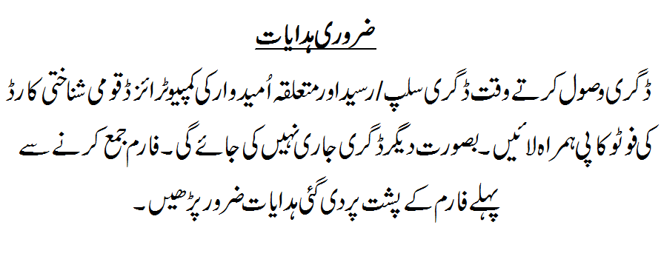
Dealing Asstt: (Degree Section)
Bacha Khan University, Charsadda

